SIMATS ENGINEERING

ASSESSMENT TOOL 1

GADI REDDY PRAKASH

192365026

MARKS: 86

COURSE NAME: INTERNET PROGRAMMING COURSE CODE: CSA4303

COURSE OUTCOME COVERED

CO-1: Develop well-structured, standards-compliant web pages using HTML/XHTML and XML, and apply Internet protocols and HTTP communication mechanisms for web content delivery. (L2)

Assessment Tool: Application-Based Questions

Weightage: 40%

QUESTIONS: Total Marks: 30

1: Online Symposium Portal
A college is developing an online symposium registration portal. The following HTML structure and HTTP interaction is observed:
<form action="/register" method="POST">
<input type="text" name="name">
<input type="email" name="email">
<button>Submit</button>
</form>
When a student submits the form, the browser sends an HTTP request to the server, and the server responds accordingly.

Questions:
- Identify appropriate HTML5 semantic elements missing in the structure.
- Modify the structure to make it standards-compliant.
- Interpret the HTTP request generated during form submission.
- Analyze the HTTP response cycle from server to browser.
- Suggest improvements for usability and accessibility.

2: Cross-Browser Compatibility Issue
A company website shows inconsistent layout across browsers. The following HTML snippet is used:
<html>
<head>
<title>Company</title>
</head>
<body>
<div>
<h1>Welcome
<p>About us
</div>
</body>
</html>

Questions:
- Identify improper nesting and missing closing tags.
- Analyze how different browsers may interpret this structure.
- Identify missing semantic elements (e.g., header, section).
- Provide a corrected W3C-compliant HTML structure.
- Suggest techniques to ensure cross-browser compatibility.

3: Form Submission Failure
A web application fails to send form data to the server. The following configuration is observed:
<form action="/submit" method="GET">
<input type="text" name="username">
<input type="password" name="password">
<button type="button">Login</button>
</form>

Questions:
- Identify issues in the form configuration.
- Analyze why the HTTP request is not triggered.
- Interpret the role of GET method in this scenario.
- Propose a corrected implementation.
- Suggest improvements for secure data transmission.

Code of Conduct:

I GADI REDDY PRAKASH(192365026) (Name / Reg No) certify that this submission is my original work and that I have adhered to the guidelines specified for this assessment.
I understand that any violation of academic integrity rules will result in disciplinary action.

Signature of the student:



RUBRICS FOR CALCULATION:
Criteria | Weig htage |  | Level 4 – Exemplary | Level 3 – Proficient | Level 2 – Developing | Level 1 – Beginning
Understanding of Concepts | 25% | 21.5 | Demonstrates thorough, accurate understanding of concepts | Good understanding with minor gaps | Basic understanding with some misconception  s | Poor understandin g; major misconceptio  ns
Explanation | 25% | 21.5 | Detailed, well-explained answers with relevant  examples | Clear explanation with adequate  details | Limited explanation; lacks depth | Poor or unclear explanation
Application | 20% | 17.2 | Effectively applies concepts with strong analytical ability | Applies concepts with minor errors | Limited application with weak  analysis | No application or incorrect  analysis
Organization | 15% | 12.9 | Well-structured answers with logical flow and coherence | Organized with minor issues in flow | Basic structure, lacks clarity | Poor organization, incoherent  answers
Accuracy | 10% | 8.6 | Completely accurate and covers all  required points | Mostly accurate with minor  omissions | Partially correct with  missing points | Incorrect answers with  major gaps
Clarity | 5% | 4.3 | Clear, neat, professional presentation | Understandable with minor issues | Limited clarity, readability issues | Poorly written, difficult to  understand

Scenario 1: Online Symposium Portal
1. Missing HTML5 semantic elements and structure
- Document skeleton: <!DOCTYPE html>, <html lang="en">, <head> with <meta charset>, <meta viewport> and <title>, and <body>.
- <header>: for the symposium title and branding.
- <main>: the primary content of the page.
- <section> with a heading (<h1>/<h2>): to group the registration content.
- <fieldset> and <legend>: to group related form controls.
- <label>: each input has none, so it has no accessible name.
- <footer>: for contact and copyright information.
- Form attributes: required, autocomplete, id, and an explicit type="submit" on the button.
2. Standards-compliant structure

<!DOCTYPE html>
<html lang="en">
<head>
<meta charset="UTF-8">
<meta name="viewport" content="width=device-width, initial-scale=1.0">
<title>Symposium Registration</title>
</head>
<body>
<header>
<h1>Annual College Symposium</h1>
</header>

<main>
<section aria-labelledby="reg-heading">
<h2 id="reg-heading">Student Registration</h2>

<form action="/register" method="POST">
<fieldset>
<legend>Participant Details</legend>

<label for="name">Full Name</label>
<input type="text" id="name" name="name"
required autocomplete="name"
placeholder="e.g. Priya Kumar">

<label for="email">Email Address</label>
<input type="email" id="email" name="email"
required autocomplete="email"
placeholder="you@college.edu">

<button type="submit">Register</button>
</fieldset>
</form>
</section>
</main>
<footer>
<p>&copy; 2026 College Symposium Committee</p>
</footer>
</body>
</html>

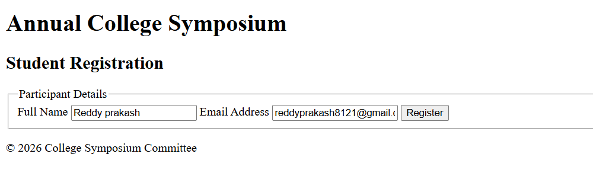
3. The HTTP request generated on submission
When the student clicks Submit, the browser serialises the fields and sends:
POST /register HTTP/1.1
Host: symposium.college.edu
Content-Type: application/x-www-form-urlencoded
Content-Length: 46
User-Agent: Mozilla/5.0 ...
Accept: text/html,application/xhtml+xml
Cookie: sessionid=abc123

name=reddy prakash&reddyprakash@gmail.com
- Request line: the method is POST, the target is /register (from action), and the protocol is HTTP/1.1.
- Headers: Host identifies the server. Content-Type is application/x-www-form-urlencoded, the default encoding for forms. Content-Length gives the body size. Cookie carries any session information.
- Body: the name=value pairs joined by &. Spaces become + and special characters are percent-encoded (@ becomes %40). The pairs use the input name attributes as keys, which is why name attributes are mandatory. Without them, the data would not be sent.
- Why POST: the data is in the body, not the URL. It is not bookmarked or cached, and it is meant for actions that change server state (creating a registration).
4. HTTP response cycle (server to browser)
- Connection: the browser resolves DNS, opens a TCP connection and performs a TLS handshake (for HTTPS).
- Server receives the request: the web server (Nginx/Apache) passes it to the application, which routes POST /register to a handler.
- Processing: the server parses the body, validates the input (required fields, email format, duplicates), and saves the registration to the database. It may also send a confirmation email.
- Response is built: the server sends a status line, headers and optionally a body, for example:
HTTP/1.1 303 See Other
Location: /register/success
Set-Cookie: sessionid=...; Secure; HttpOnly
Common status codes:
- 200 OK: success, page returned directly.
- 201 Created: registration created.
- 303 See Other: redirect to a success page (the Post/Redirect/Get pattern, which prevents duplicate submissions on refresh).
- 400 or 422: invalid input.
- 409: already registered.
- 500: server error.
- Browser handling: it follows the redirect with a new GET /register/success, receives the HTML (Content-Type: text/html) and parses it into the DOM. It then fetches CSS, JS and images, builds the render tree, and paints the page.
- Connection: it is reused through keep-alive or closed.
5. Usability and accessibility improvements
Usability
- Use clear labels and helpful placeholders. Validate on the client (required, pattern, type="email") and always on the server as well.
- Show inline error messages next to fields, and keep entered values when validation fails.
- Display a clear success confirmation page or message, and send a confirmation email.
- Make the layout responsive, mobile-friendly and touch-friendly (large buttons).
- Add autocomplete attributes and extra fields (department, year) if needed.
Accessibility
- Associate every input with a <label for>. Use fieldset/legend for grouping.
- Make everything keyboard-navigable, with a visible focus indicator and logical tab order.
- Use ARIA only where needed, for example aria-describedby for hints and role="alert" or aria-live for error messages.
- Ensure sufficient colour contrast (WCAG AA 4.5:1) and don’t rely on colour alone to show errors.
- Use semantic landmarks (header, main, footer) for screen-reader navigation, and test with a screen reader and Lighthouse or axe.
Security: use HTTPS, a CSRF token and CAPTCHA/rate-limiting to prevent bot sign-ups.

Scenario 2: Cross-Browser Compatibility Issue
1. Improper nesting and missing closing tags
- <h1>Welcome has no closing </h1>.
- <p>About us has no closing </p>. (HTML5 allows </p> to be omitted in some cases, but it is bad practice.)
- A <p> is placed inside an <h1>, which is invalid. Headings may contain only phrasing content, not block elements like <p>.
- Missing <!DOCTYPE html>, lang, <meta charset> and viewport meta.
- No semantic structure: everything sits in a generic <div>.
2. How browsers interpret it
- Without a DOCTYPE, browsers enter quirks mode, emulating legacy behaviour. This causes differences in box model calculation, default font sizes in tables, line heights and so on, which is a major cause of inconsistent layouts.
- Modern browsers follow the HTML5 parsing algorithm and error-recover the same way: they implicitly close the <h1> and <p> when </div> is reached. The <p> often ends up inside the <h1>, which inherits the large, bold heading style. This is a different result from what the author intended.
- Older browsers (like old IE) and non-compliant parsers recover differently, so the DOM tree, and therefore CSS selectors and layout, may differ.
- Without charset, the browser may guess the encoding and display garbled characters.
- Without a viewport meta tag, mobile browsers render at a desktop width and scale down.
- The result is that the DOM differs by browser, so identical CSS yields different layouts.
3. Missing semantic elements
<header>, <nav>, <main>, <section> (or <article>), <footer>, and a <h2> for the About section. A <div> conveys no meaning to browsers, search engines or screen readers.
4. Corrected W3C-compliant structure
<!DOCTYPE html>
<html lang="en">
<head>
<meta charset="UTF-8">
<meta name="viewport" content="width=device-width, initial-scale=1.0">
<title>Company</title>
</head>
<body>
<header>
<h1>Welcome</h1>
</header>

<main>
<section id="about">
<h2>About Us</h2>
<p>About us</p>
</section>
</main>

<footer>
<p>&copy; 2026 Company</p>
</footer>
</body>
</html>


5. Techniques for cross-browser compatibility
- Always use the HTML5 DOCTYPE to trigger standards mode.
- Validate with the W3C Markup Validator. Close all tags and nest properly.
- Use a CSS reset or normalize.css to remove default style differences.
- Use box-sizing: border-box, Flexbox and Grid with fallbacks, and relative units (rem, %).
- Use vendor prefixes where needed (via Autoprefixer) and check support on caniuse.com.
- Use feature detection (@supports, Modernizr) instead of browser sniffing, and polyfills or progressive enhancement for newer features.
- Use responsive design with media queries and the viewport meta tag.
- Test on Chrome, Firefox, Safari and Edge, and on real devices, using BrowserStack or LambdaTest.
- Use Babel for transpiling JavaScript and a browserslist configuration.

Scenario 3: Form Submission Failure
1. Issues in the form configuration
- <button type="button">: this is a plain button that does not submit the form.
- method="GET" is inappropriate for credentials, since the username and password would appear in the URL.
- No <label> elements, so there is no accessible name for the inputs.
- No required attribute or validation, so empty submissions are possible.
- No autocomplete hints, and no HTTPS or CSRF protection.
- No id attributes on the inputs, so labels cannot be linked.
2. Why the HTTP request is not triggered
A <button> defaults to type="submit", but here it is explicitly set to type="button". Buttons of this type have no default action: clicking them neither submits nor resets the form. Unless JavaScript (onclick calling form.submit() or fetch) is attached, nothing happens, so the browser never builds or sends the HTTP request. The server receives nothing, and the form appears “broken”.
3. Role of the GET method in this scenario
If the button did submit, GET would append the data to the URL as a query string:
GET /submit?username=john&password=secret123 HTTP/1.1
Consequences:
- Credentials are exposed in the address bar, browser history, bookmarks, server and proxy logs, and the Referer header sent to other sites.
- URLs have length limits, and responses can be cached.
- GET is meant to be safe and idempotent, used for retrieving data (search, filters), not for authentication or state changes.
So even after fixing the button, GET is the wrong method for a login form.
4. Corrected implementation
html
<!DOCTYPE html>
<html lang="en">
<head>
<meta charset="UTF-8">
<meta name="viewport" content="width=device-width, initial-scale=1.0">
<title>Login</title>
</head>
<body>
<main>
<h1>Login</h1>
<form action="/submit" method="POST">
<input type="hidden" name="csrf_token" value="{{ token }}">

<label for="username">Username</label>
<input type="text" id="username" name="username"
required autocomplete="username">

<label for="password">Password</label>
<input type="password" id="password" name="password"
required minlength="8" autocomplete="current-password">

<button type="submit">Login</button>
</form>
</main>
</body>
</html>

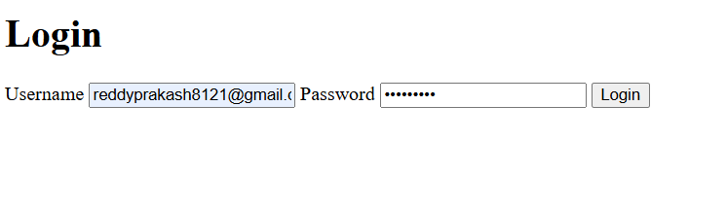
The two key fixes are method="POST" and type="submit".
5. Improvements for secure data transmission
- Serve the site over HTTPS/TLS only. Redirect HTTP to HTTPS and enable HSTS.
- Use POST, so credentials go in the request body, never the URL.
- Hash passwords on the server with bcrypt/Argon2 (salted). Never store or log plain text.
- Add a CSRF token and set cookies with Secure, HttpOnly and SameSite.
- Validate and sanitise on the server to prevent SQL injection and XSS. Use parameterised queries.
- Implement rate limiting, account lockout and CAPTCHA against brute force. Add multi-factor authentication.
- Send Cache-Control: no-store on authenticated pages, and add security headers such as CSP and X-Frame-Options.
- Use generic error messages (“Invalid credentials”) so attackers can’t enumerate usernames.

